Gabriel Galarza, Luka Antolic-Soban, Klaus JianMing Zeng

UHE

CS 4590

Github: <https://github.com/klauszeng/Team-Project-UAE>

Google Drive: <https://drive.google.com/drive/folders/0BwgkFKgDC6MNZm8taE1vYV81Wnc>

**Project Description**

In surgery rooms, many sterile procedures must be followed in order to maintain a sterile environment for those operating in the room as well as for the patient. These procedures include keeping the hands above the waist, maintaining an appropriate distance at times from others in the room as well as unsterile environments, and passing another person in room with a person's back facing another person’s front. If medical personnel at any point leaves the sterile environment or breaks one of the three procedures above, they must leave the room immediately and re-sterilize.

Often times, there are more than 5 people in a surgery room at a time and it is difficult to make sure that everyone is following sterile procedures, which leaves individuals to be accountable for themselves. In some cases, one person may be designated to be accountable for sterilization but this can be a hard task for one person to monitor.

We look to relieve that burden with a wearable audiocentric device that alerts those in the the surgery room when they are unsterile or simply reminds them to double check their surroundings. This device would be able to use sensors to communicate with other gowns in the room in knowing each person's location as well as the location of each person's hands in proximity to their bodies. The design of the solution below illustrates in detail how each use case will be handled.

**Process**

**Ideation**

Initially, our group looked to start our ideation phase by brainstorming appropriate tones and sound volumes for the surgical environment as well as find possible candidates in the medical field to interview in regards to their experience in the surgery room. We looked to ask about the sterilization process of the surgery room and what constitutes as an infraction in maintaining a sterile environment. The sounds that we brainstormed will also be presented to the interviewees to gain feedback on its usability. We then looked to gain feedback on our drafted design solution from the interviewee and then forward our questions to more contacts within the clinic.

Tentative Audio Cues

Ambient Sounds - Proximity Warning

* The group looked to have a periodic beep that was dull and it would signify how far away one person was from another. This sound would essentially warn others from being too close to one another and causing one another to become unsterile through inappropriate contact. As a person in the sterile environment gets closer to another person, the beeping frequency and volume would slightly increase. If two people are much closer than 2 feet, the high ambient sound would play with the highest frequency and volume of all the ambient alerts.

Alert Sounds

* Low alert - This is a reminder alert to let the medical personnel to check their surroundings and make sure everything looks to remain sterile.
* Medium alert - This alert will be sounded if hands seem to be going below an unsterile level on your body. It would be a warning alert to let the user know to bring their hands to a safer and more sterile height.
* High alert - This will be the loudest and most obnoxious of the alerts which will be signifying that unsterilization has occurred and that the person should leave the room immediately and re-sterilize.

Notes from Interview with Richard including feedback from more Santa Clara Medical staff

Sterilization Rules

* Front of gown is sterile
* Back of gown is NOT sterile
* Medical personnel always pass each other back to back or front to front .
* Below elbows should be above waist with hands up
* Can’t touch anything unsterile with hands
* Sterile towels on table can be used
* There should be at least 18 inches between people

Sterilization Process

* Scrub hands for 5 minutes
* Walk into surgery room and there will be sterile 2x2 table with sterile towel to dry hands
* Place sterile gown on over your front, followed by sterile gloves, then scrub nurse helps tie the back of the gown

Room View

* Patient is in the center of the room
* Anesthesia is behind the patient
* Parallel to the patient is a sterile table with sterile instruments on top of it with about 3 to 4 feet of space to walk through.
* Emory medical staff

Current Sounds Heard in the Environment

* Vital sounds - beeps for the heart rate , it can get frequent and sharp
* Certain devices have beeps to determine if its working or not. usually suttle, not sharp.
* sharp tones are usually coming from patient vitals.

Feedback of our current Sounds

* Try to utilize frequency and loudness
* Possibly use three beep sequence with combination of lights to alert someone of warnings

**Prototype**

With the given feedback, the group moved forward with creating a prototype for the wearable audiocentric device on the gown. A processing simulation was created to simulate our three use cases which are 1) keeping elbows above waist 2) keeping 2 feet of distance from other personnel in the environment 3) making sure you’re passing other personnel back to back or front to front (the back of the gown is unsterile). The simulation demonstrates the different sound cues for the different use cases as well.

Processing Simulation Screenshots

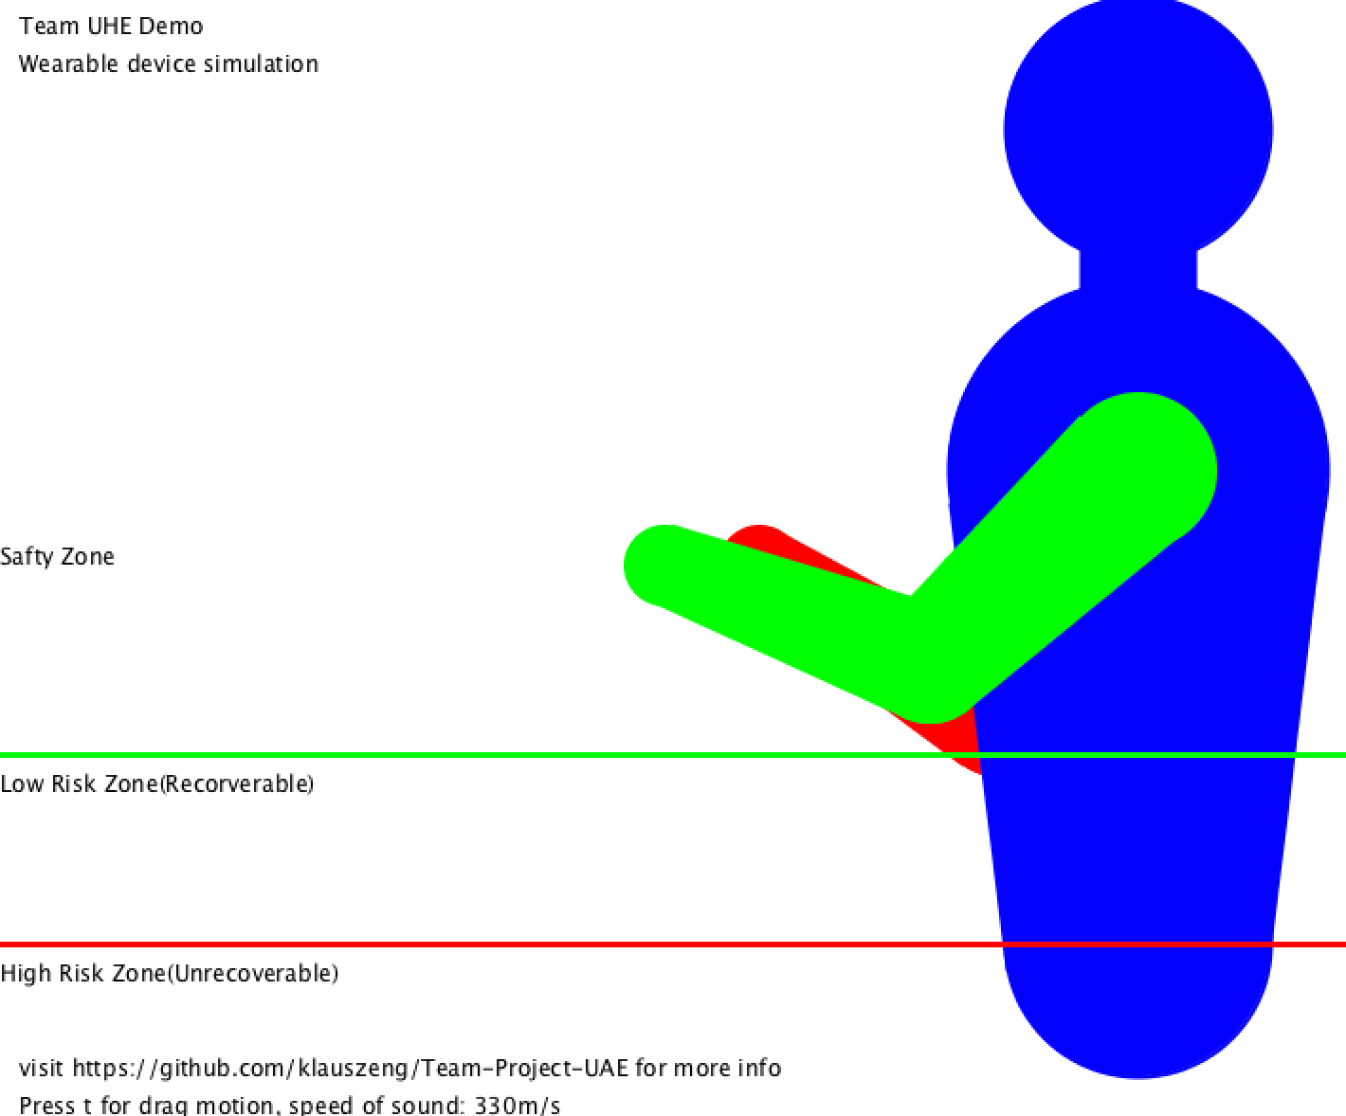

Simulation Demonstrating hands needing to be above waist.

Sound Localization Diagram used for Sonification.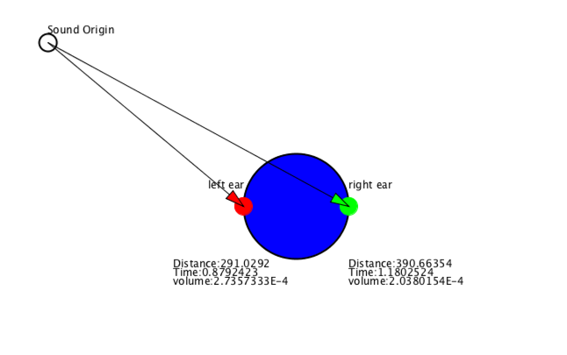

Surgery Room Simulation Testing Distance.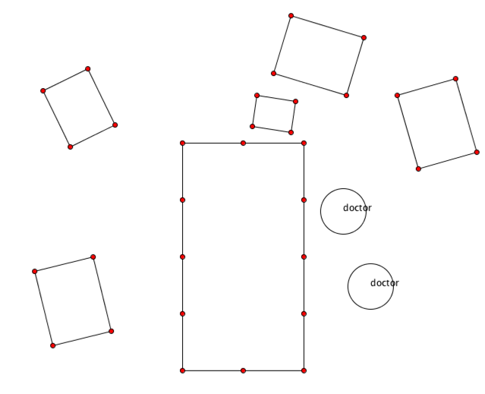

Each gown will be equipped with the proposed hardware below. The main Bluetooth LE micro unit as well as the battery will be attached to the gown on the back of it right in between the shoulder blades. The device can be charged via micro usb when not in use. The entire unit will be sewn in between the fabric inside a waterproof plastic enclosure where the unit may be removed when cleaning the gown.

Block Diagram of Device

For hardware, our device will use:

* Adafruit Bluefruit LE Micro
* Adafruit Pro Trinket LiIon/LiPoly Backpack Add-on
* Stereo 2.1W Class D Audio Amplifier
* Lithium Ion Polymer Battery - 3.7v 500mAh
* 8 ohm 0.25W Speakers
* LED indicator



Model Diagram for device

The model was made using Modo 3D. Each of the major components are present. In the middle is the Microcontroller, Bluetooth Module, as well as a battery. Then moving away from that we have 2 speakers, each on the shoulders facing upward. Finally, at the forearms are gyroscope modules to make sure that the arms are positioned as needed in space.

(side view)

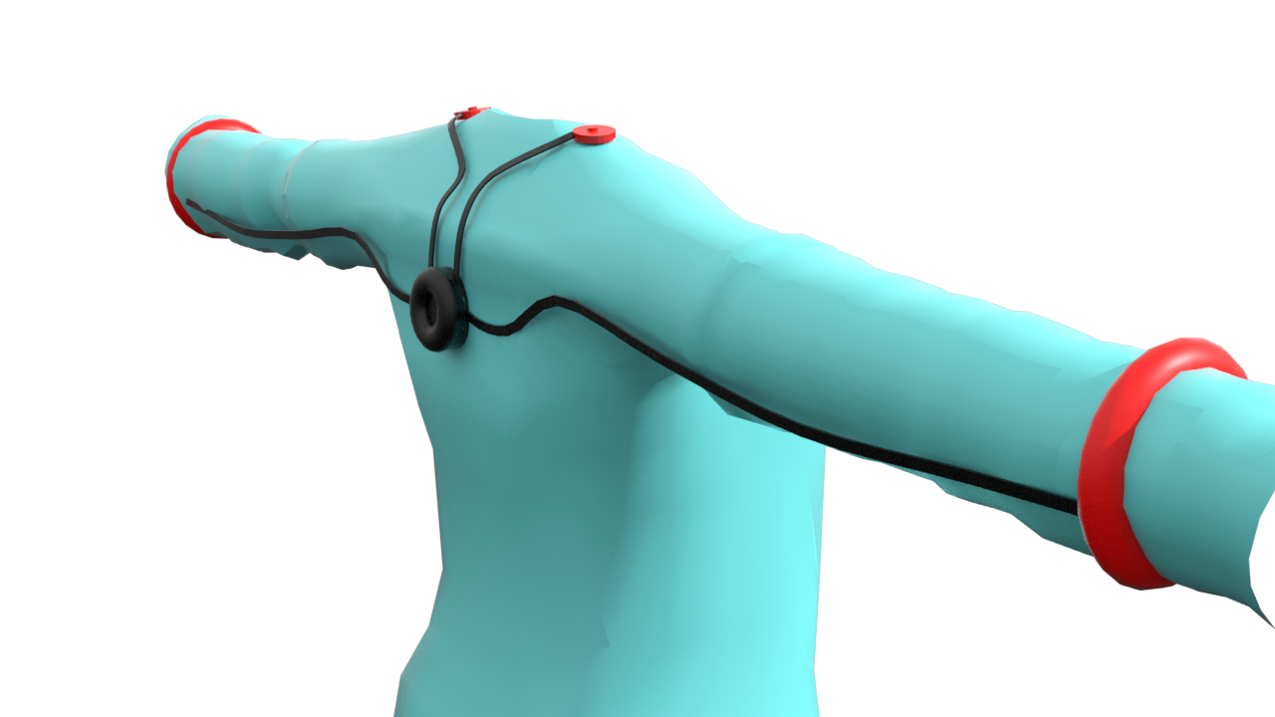

(face view)

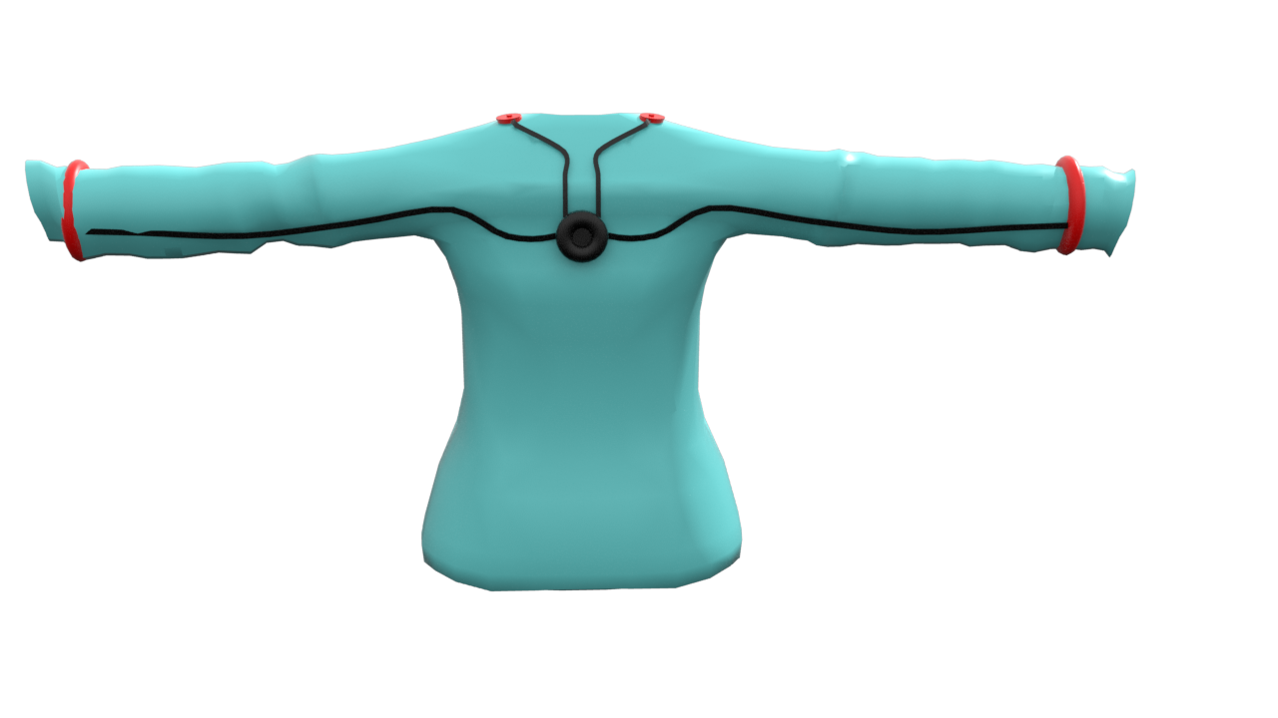

On Female Model

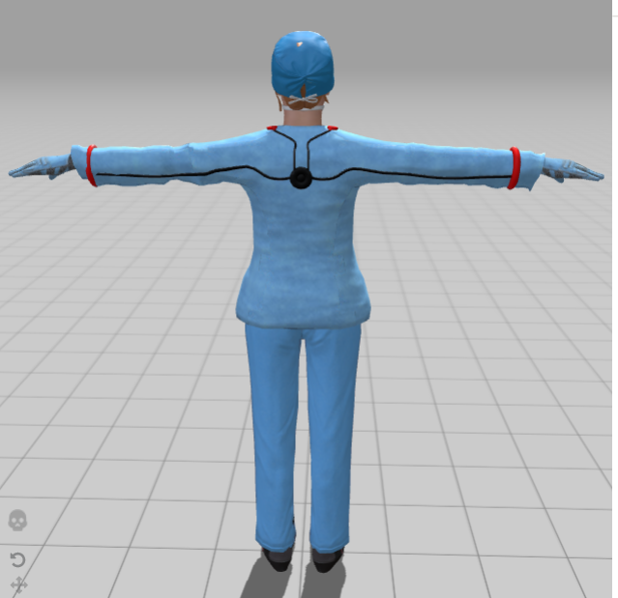

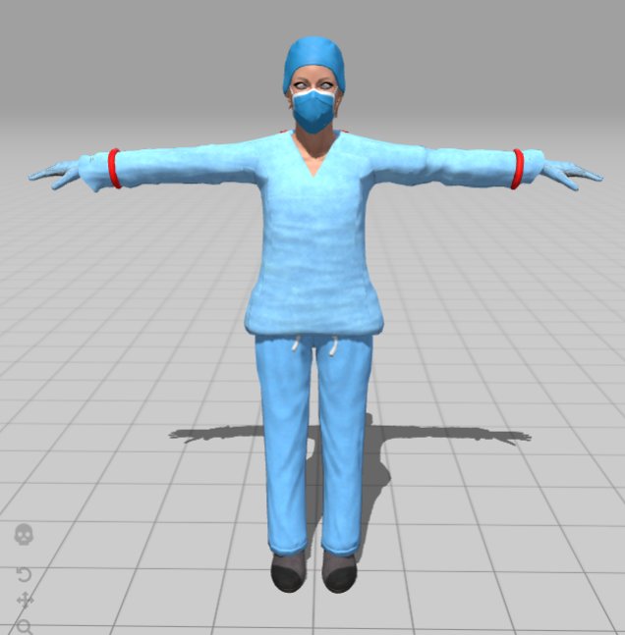

User Feedback on Current Design

The team contacted our previous medical staff in Santa Clara Hospital staff as well as well as another interviewee from Emory Hospital.

Santa Clara Medical Feedback on Sound Cues

* “I like the low to high ambient alarm sounds because they have consistent beeps that aren't irritating although they serve the purpose of alarming for potential proximity alerts.”
* “The low to high alerts would be more appropriate for more serious alarms because the sound beeps aren't consistent and more annoying.”
* “More annoying and louder alarms usually indicate physiological and malfunctioning equipment alarms.”

Interview with Marlene from Emory

* Hands are the most important part of sterilization. Measure the hands proximity as opposed to the elbows.
* "Infractions “ is the word used to describe breaking sterile codes
* Good idea to have reminder to wash the hands and maybe dry the hands
* people may get close when in a surgical wound - holding a clamp, so this may be challenging to measure proximity in an accurate way unless you can turn it on and off.
* Instead of having a design with sound playing that would confuse others you could possibly use unique sounds to each person, but with similar effects and tone
  + Can also just move the audio output near the shoulders of the gown
* Sometimes people will listen to the radio in surgery room so periodic sounds may be annoying to the people there. If it's too much then it can be exhausting.
  + figure out how sensitive and how frequent these sounds can be

**Sonification:**

In order to maintain the quiet environment, we divided to sonify information in the smooth and slow manner**.** Currently, we have two different tones, one for OR personnels and one for any other obstacles (medical equipment). These tones are triggered if any obstacles or users gets closes to others. Instead of at their max volume, all sounds start softly initially, and get louder and louder if distance between users or obstacles continue being closer. We hope that the users adjust the distance based on the volume of sound. The volume follows the Inverse-square Laws:

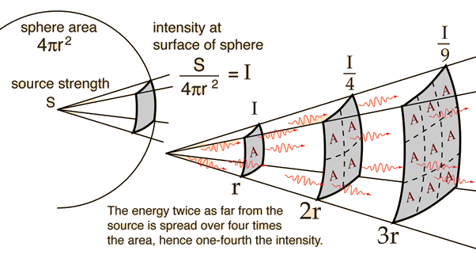

or

In the equation, intensity is the sound volume and it’s associated with the distance of the sound origin. Intensity 1 and Distance 1 as in processing, the volume control by bead is max at 1. And this number will decrease exponentially along with the distance. Distance 1 is associated with Intensity 1 and therefore is a relatively small number. In the 2D simulation, the canvas is 1200 pix by 600 pix and therefore we set it to 1 for convenience. In real world setting, this number can be enlarge to fit the need of volume. Also, in our 3D model, there are two speakers on both shoulders. This design is for user to better locate the incoming signal origin. For the speed of sound, we use 330 m/s for calculation. We calculate the difference between time needed for sound to travel from origin to the device wearer, and amplify that the difference by 10 in order to make the delay more obvious between ears. This design gives the illusion that the electronic signal is transmitted through air, and with that delay between sound arrive at two ears, user has a more accurate read of where the signal is coming from and therefore easier to adjust their position correctly.

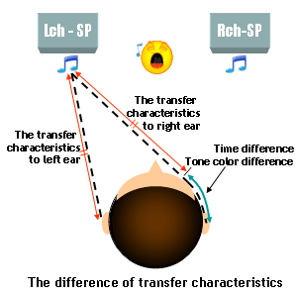

**Simulation**

The group used our drafted prototypes and presented to the class and our user groups. We used the given feedback to make alterations to our prototype and finalize our simulations for the final presentation.

The group finalized the processing simulation to incorporate the sounds into a surgical environment. This simulation focuses on illustrating the different use cases for the sound cues.

Processing Instructions

*Instructions*

1. Install processing in order to run the full simulation.
2. Under the simulation.pde tab, simulations are commented out. Look for the one desired, uncomment the function and run the codes.
3. Press ‘t’ on the keyboard(case sensitive) and interact with points in the simulation.
4. Repeat step 2

Unity 3D Instructions

A Unity 3D simulation was created in order to demonstrate the Design of the Hardware placed onto the surgical gown. This simulation shows sounds coming from the suit to alert the medical personnel accordingly.

*Please refer to the readme.txt inside the Unity and Simulation folder for all instructions regarding this.

**Member Contributions**

Luka

* Created initial idea of audio wearable
* Researched hardware and created an external design of the device
* Created 3D model of the medical gown.
* Created 3D simulation and video in Unity to give better understanding of the device and real-world scenarios.

Jianming

* Researched some of the most used sonification techniques
* Implemented an algorithm incorporates Inverse-Square law and sound localization for the sonification process
* Created 2D simulations for three use cases.

Gabriel

* Created the sound cues for the ambient and alert sounds of the Audio Sterilization Assistant Design. OcenAudio and FreeSound.org were used in order to edit and develop the sounds for the design.
* Led Interviews with medical personnel from Santa Clara Medical and Emory Hospital and collected feedback
* Worked on creating skeleton for final project documentation

**Appendix**

**Project Description 1**

**Process 2**

Ideation 2

Tentative Audio Cues 2

Interview with Santa Clara Medical 2

Prototype 3

Processing Simulation Screenshots 4

Device Block Diagram 5

Model Diagram 6

Interview with Emory 9

Sonification 9

Simulation 11

Processing Instructions 11

Unity Instructions 11

**Member Contributions 12**